A PROFILE OF THE LBSCR TERRIERS - ‘GIANTS’ OF THE STEAM AGE

Our locomotive Martello is arguably one of the most long-lived, versatile and successful classes of steam locomotive ever designed in this country.

In 1870 William Stroudley was appointed locomotive superintendent of the London, Brighton and South Coast Railway Company. He inherited a chaotic motive power situation, with dozens of non-standard classes. Over the next few years Stroudley proceeded to introduce a series of around 8 standardised types to cover all the traction requirements of the company.

One of the first was the A class 0-6-0 tank engine. These locos were intended for suburban commuter services in south and southeast London, at that time growing steadily. They were however fashioned with specific routes in mind – to run intensive ‘block’ trains on a semi-circular path from London Victoria, through inner south London, to London Bridge station. They also ran from New Cross to Shoreditch, via the East London Railway, through Marc Brunel’s Thames tunnel, linking into the Great Eastern Railway’s then terminus at Bishopsgate and later Liverpool Street. For both routes a very small and lightweight engine was required – the rails on the south London section were reputed at this time to be fragile wrought iron, capable of supporting only the lightest axle loading. The A class weighed in at barely more than 24.5 tons. But the engine also needed to accelerate 100-ton trains rapidly between closely spaced station stops to very tight timings. These trains consisted of about 10, close coupled, 4-wheeled wooden carriages, also designed by Stroudley - and initially unbraked, relying on the engine brakes alone.

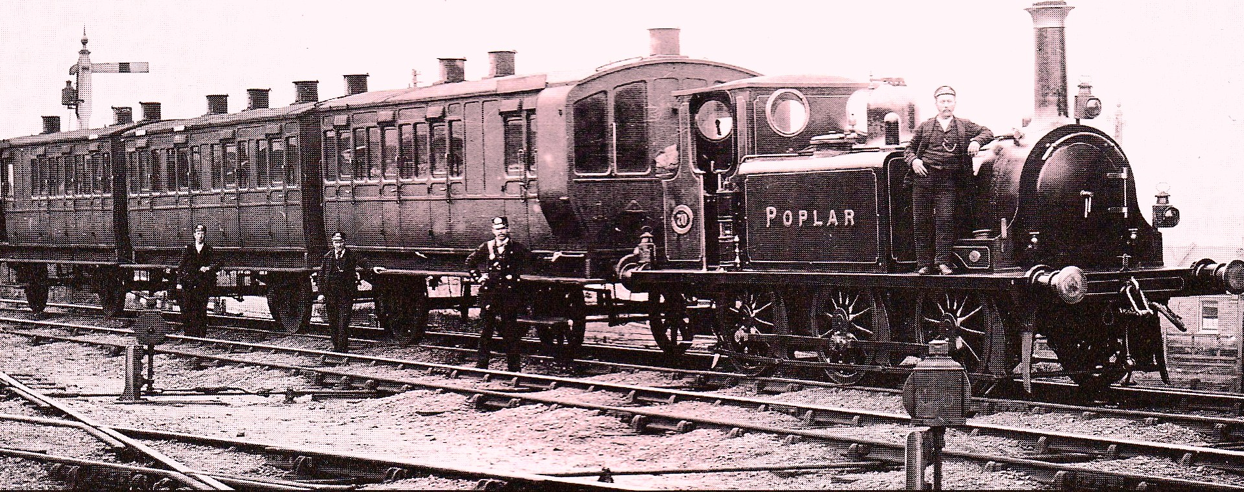
Ian Allan Library/Bucknall & Derek Brough Collections

So Stroudley spent much effort getting the design just right – altering it 3 times before the initial construction stage. The first 6 locos were out-shopped from Brighton works in 1872 and immediately proved more than capable, being surprisingly powerful and quick for their size. The A class were from the start popular and highly regarded by all. Engine crews nicknamed them ‘Rooters’. But the name best associated with them was first heard within months – the Terriers – their sharp performance and distinctive bark well suiting this.

A sole main line duty in the early days was taking over a portion of the Newhaven Continental Express (both Up and Down direction) between London Bridge and East Croydon; speeds up to 60mph were often achieved passing through New Cross. This would require the A class 4ft driving wheels to be revolving at more than 7 times per second!

Production of the class continued from 1874 up to 1880, until a total of 50 were out-shopped, all from Brighton. Most were given names of places within the LBSCR orbit, having a numbering sequence from 35 to 84. These engines did not then appear quite as Martello does today – they had slightly smaller diameter boilers, copper topped chimneys, shorter smokeboxes, flared ‘wings’ on the smokebox front and sandboxes forming a forward extension of the front wheel splashers. They were also fitted with condensing pipes and vents on the side tanks – following on from Stroudley’s practise of preferring feed water pre-heating to improve thermal efficiency and pumps over injectors. The locos appeared in his famous and distinctive ‘improved engine green’, which was actually a golden ochre colour. This difference has been wrongly attributed to colour blindness but was just a further development of what had been up to then a standard green livery applied almost universally in Britain. Indeed Stroudley is noted for his aesthetic sense and produced some of the best looking engines of the time, the Terriers being top contenders. The first engines were initially fitted only with wooden brake blocks and relied on an inconsistently performing steam brake, or just a hand brake. The urgency with which they were needed in traffic prevented any more developed braking systems being introduced. But within a few years Stroudley had become an advocate of air braking and had the earlier engines retrofitted with Westinghouse pumps. All later locos were so fitted during construction. He persuaded the company to adopt air braking on all their rolling stock.

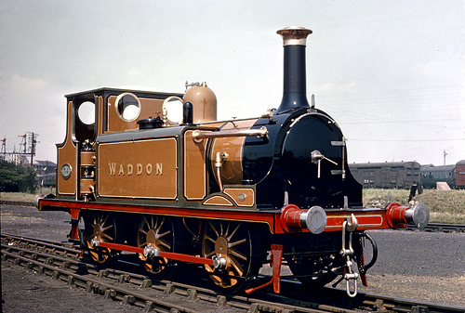

During the last two decades of the 19th century London expanded dramatically, with once separate towns such as Croydon, Norwood and Sutton now part of the conurbation. This was in no small way due to the effect of the Terriers themselves, which had speeded up commuter services encouraging more people to move out of the city. They became early ‘victims of their own success’, unable to cope with the heavier trains needed and they were replaced with more powerful engines (Stroudley’s ‘D’ & ‘E’ class tank engines). By the late 1890’s the first scrapping schedule was proposed over a 4-year period, the engines being placed on a ‘surplus list’. From 1900 onwards, following LBSCR practise, they were ‘duplicate listed’ and re-numbered with an additional 600 to the original number to make lower numbers available for newer classes. So No. 62 Martello became No. 662. A reclassification also took place from 1901 and the engines became class A1. The names were removed from the side tanks and replaced with the inscription LBSC. They were also re-liveried by Stroudley’s later successor Douglas Marsh in a smart umber colouring.

Despite seven being scrapped, the little engines had shown themselves very adaptable – this was to ensure their survival on several future occasions. Marsh considered they still had many other uses. The majority of the 25 locos withdrawn at this period were sold on. They were ideal for branch line work on light railways, light freight turns and departmental & shunting duties. Newhaven Harbour, The Isle of Wight railways, and what is now the Kent & East Sussex Railway were all recipients of the locos. Some even ended up abroad.

A crucial moment in their salvation was the LBSCR’s decision to adopt motor-train push-pull operations, to improve flexibility on many branch lines and counter competition from a growing electric tram network. Several engines were modified for this work. In 1911 the new Loco Superintendent Lawson Billington gave a further lease of life to the Terriers and initiated a re-building program for those remaining with the LBSCR. 12 were rebuilt between 1911-1913 and a further 4 after the Great War. The engines now became class A1X – the boilers and cylinders were enlarged, giving more power and increasing their weight to over 28 tons. The smokeboxes were extended, which required removal of the wings and relocation of the sandboxes (on most rebuilds) to under the running plate. The condensing apparatus was also removed. Other changes included replacing any life expired copper topped chimneys with plain types and enlarging the bunkers on some engines.

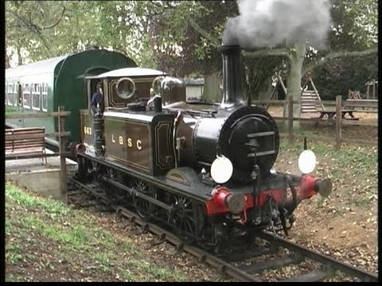

The remaining stock of Terriers was augmented when a number of former LBSCR engines that had been sold off were absorbed into the new Southern Railway, along with their constituent companies, during the grouping of the Big Four in 1923. This increased the fleet back to 24, although withdrawals and scrapping continued over the coming years, albeit on a very gradual basis as in the first round of reallocations. Under the Southern’s new numbering system all ex LBSCR locos were given numbers pre-fixed with the letter B (indicating a Brighton area origin) or letters indicating their allocation, those on the Isle of Wight railways being pre-fixed with a W. In 1931 the Southern instituted another change by adding 2000 to the original numbers. Along with all other motive power under the new regime the engines now had a further change of guise and appeared in Southern Railway green.

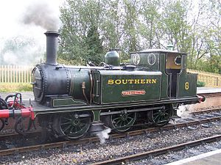

And so life went on for the surviving Terriers in the Southern Railway. They continued where other classes of pre-grouping tank engine were retired because the Southern system had so many light railways with weight restrictions. As investment was concentrated on newer classes of main line steam locomotive and electrification it was not considered worthwhile spending on new engine building for relatively unprofitable branches. The Terriers were the best motive power solution on these lines.

Fast-forward to 1948 and the railways of Britain are nationalised, forming British Railways. 15 A1X’s and one A1 entered public ownership on the 1st January of that year. They all got yet another make over – into BR lined black with a further re-numbering. 30,000 was added to the existing numbers, giving Martello her final guise as No 32662

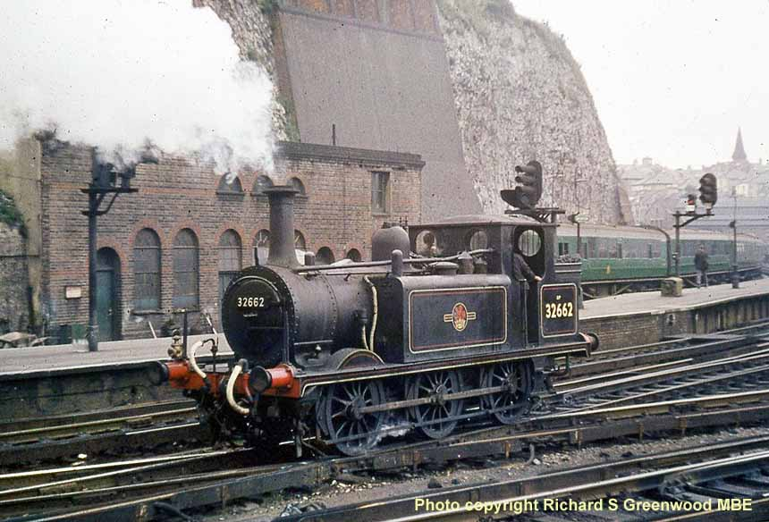
(Martello at Brighton in the BR era)

During the BR era the future and viability of the Terriers was at last in doubt – they were becoming increasingly difficult to maintain due to sheer age and wear and tear. Also the light railways where the engines worked were becoming uneconomic and closures were scheduled. One of the final two outposts of the class, the Kent And East Sussex branch was closed in 1961. This just left the Hayling Island line – a four ½ mile branch from Havant on the main land, running over a wooden trestle bridge at Langstone and onto the south of the island. It had been worked by the A1X’s for many years because of a severe weight restriction on the bridge. However it remained profitable and became the last stand of the Terriers in revenue earning service.

Martello re-joined two other A1X’s there and received a final modification; a lengthened bunker to increase coal capacity and extend the engine’s running between servicing. The Hayling Island line was an archaic, decrepit affair, one of many such that lent so much charm, depth and variety to the railways of Britain in the 50’s and early 60’s. Sadly even here time caught up at last. The Langstone trestle bridge was deteriorating and it was deemed not cost effective to repair it. So closure was announced and took place in November 1963. The working life of Stroudley’s Terriers was over after 90 years.

But for 10 of the Terriers this was still not the end of the story. The railway preservation movement was just getting underway at this time. As they had proved so many times before the locos were the ideal motive power for these short and lightly laid preserved railways. Many were bought up and sent immediately to nascent heritage lines, such as the Bluebell in Sussex. Martello went in a more unusual direction and was one of three A1X’s purchased by Butlins Holiday Camps for static display at their seaside venues. She spent the rest of the 1960’s at Ayr.

In 1970 Alan Bloom approached Butlins with a view to acquiring and preserving some of their static locomotives, which were becoming degraded from exposure to sea air and spray. Butlins was happy to release them on loan and so Martello, with some other large main line locos, arrived at Bressingham in early 1971, to add to Alan’s growing collection of steam engines. She was repainted into her 1909 Marsh umber livery. In 1992 the museum bought the engine outright from the Rank Organisation (then owners of Butlins properties).

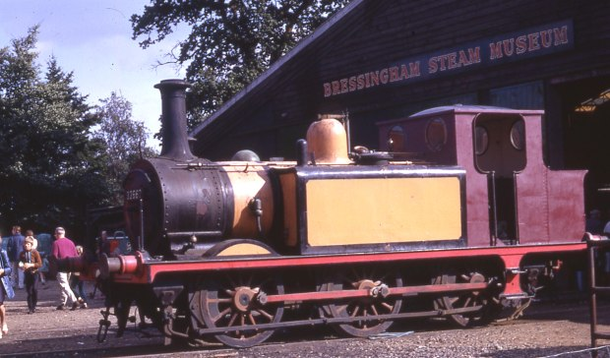
(Martello on arrival at Bressingham in 1971)

In 2005 with the aid of an HLF award Martello was returned to life. First in her LBSCR appearance she steamed regularly at Bressingham and toured the country’s heritage railways near and far. Unfortunately in 2011 some problems with her boiler developed which caused an early retirement. Her certification expired in 2012.

But due to the commitment and hard work of many people at Bressingham, both up front and behind the scenes, Martello is set to begin yet another episode in an incredibly long and varied career. It was thought the loco would make an ideal candidate for overhaul. The current restoration project is the fruit of that. However we need help to make it happen – please contact the Bressingham Steam Museum office if you wish to donate. Our Terrier will appear this time in Southern Railway green for the first time in 70 years – the only A1X livery not yet used in her preservation history.

In 2015 she celebrated 140 years since first out-shopped!

References:
Stroudley and his Terriers; Tom Middlemas; Pendragon (1995)
Stroudley Locomotives; Brian Haresnape; Ian Allan (1985)
British Steam Railways (issue 30); DeAgostini/Planet 3 (2006)

